Swing Analysis User Acceptance Test Plan and Results

Jared Matteson

Software Engineering, Dunwoody College of Technology

SENG 4210: Senior Project 2

Joe Axberg

May 4, 2022

Table of Contents

Executive Summary 3

How to Install the Golf Swing Analyzer 4

Configuring the Golf Swing Analyzer 6

Running the Golf Swing Analyzer 8

Pictures of the Project 10

# Executive Summary

Almost every year there are about five hundred thousand new golfers that take their first swings, either on the course at a driving range, etc. To try and help make golf and more specifically the swing easier to get the hang of, I have attempted to create a object tracking application that would allow for people with a computer at home and a phone to record videos with, the ability to work on a better swing with actionable input. Golfing is already one of the hardest sports to be okay at, and without any rhyme or reason to your practice, you already put yourself at a severe disadvantage. Do not make golf harder than it has to be and practice with a purpose. One of the biggest things I found helpful was watching my swing path on recordings of my golf swings as well as getting feedback from indoor driving ranges where they give you metrics on swing path and face position relative to swing path. I used to slice the ball severely and with practicing getting my swing path more in to out rather than out to in I have been able to correct my slice.

To enable the user to see a more defined look at their swing path I am leveraging OpenCV, which is library focused on real-time computer vision and python which is a rather easy to understand programming language. OpenCV is open sourced and readily available with documentation and python is one of the easiest and best ways to get started with implementing OpenCV.

# How to Install the Golf Swing Analyzer

1. Download and install Python 3.9
2. Download and install PyCharm Community Edition
3. Download and install OpenCV version 4.5.5
4. Add python and open cv to your system environment variables path
   1. Graphical user interface, text, application, email

      Description automatically generated
   2. Graphical user interface, text, application

      Description automatically generated
   3. In a. you can see the System Environment Variables Pop up window select Environment Variables
   4. Then in b. you select Path and click edit and you add the file path of corresponding bins for both Python and OpenCV often times they will also have the option to add to your path during the installation process.
5. Download source code from the GitHub repository <https://github.com/jaredMatteson/SwingAnalyzerCapstone.git>
   1. This can be done through zip file downloads on GitHub or through cloning the repository and making pull requests on GitHub.

# Configuring the Golf Swing Analyzer

Currently as the Swing Analyzer is set up, it will read Bright Orange heads of clubs. For your particular setup you may need to change the color the program is looking for (as a side note it is recommended that bright colors are used when attempting to analyze your swings). You will need the Hue, Saturation, and Value spectrum you are attempting to operate within. You can do this with some online tools such as ColorPicker.me to get started and a picture of the object you wish to track. I found my values to be in the neighborhood of 6,100,70 as my lower limit and most online tutorials suggested having a fixed upper limit 25,255,255, but this could be refined to get better accuracy and more definition of the object you are tracking.



For the video format I am using mp4 because it is the most common, you may run into problems using .MOV files which originate from iOS devices. Make sure you also change the path of your media folder to your own path not mine. Obviously, you do not have my computer so if you wanted to use your media you have to switch the path on page 8 to your own path so that your media will be accessible. You may also at this point need to add come packages to PyCharm so that it knows what it is seeing and can recognize the libraries that are being used. For this we need to go the setting of PyCharm by doing File then Settings. This dialog box will pop up showing options for plugins and a whole bunch of other junk we are not worried about right now. You will see on the next page.

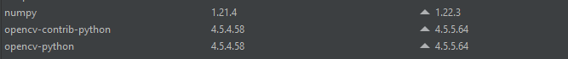Once you are here you want to click on the Project drop down tab and then click the blue “Python Interpreter” option. Then you find yourself in the dialog box above showing all your packages, yours will most likely be empty. For this project you will need the following packages.

You can add the above packages by clicking the + sign in the corner just above the column name “Package”, which should pop up a search menu and you can search for the packages word for word as you see them above and install them. This will help when referring to the specific methods within each library that I have used.

# Running the Golf Swing Analyzer

When running the Golf Swing Analyzer there are a few things to be wary of. One is making sure you are using the correct camera angle so to ensure you get a correct reading of the path angle. Ideally you are recording behind the golfers swing so you can see the backswing and downswing planes appropriately (see below).

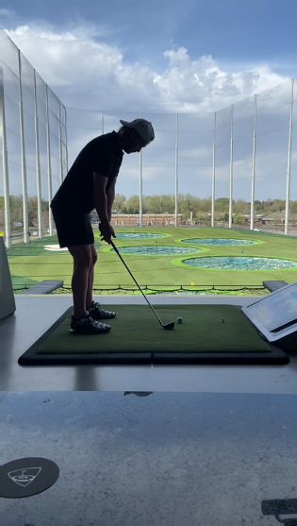

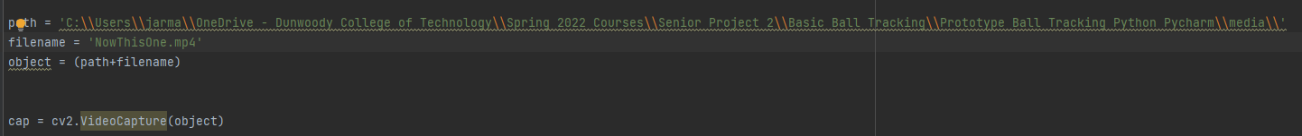 Another thing is making sure the videos you are using are edited correctly. For the videos slowing them down to .75x or even .50x speed helps tremendously as well as making sure your videos are in landscape mode instead of portrait as golf swings can be rather wide, large movements, still making sure you get the full swing in the video frame. When selecting your video in the Golf Swing Analyzer, for now you will have to specify the video in the code itself just like what you see below.

Above you can see that my path to where I am storing my media is specified and the corresponding file I am attempting to use within the media folder is also specified with the variable ‘filename’. I made it somewhat easier on myself by make a third variable called object here that concatenates the path and the filename so that I don’t have to specify a path every single time I want to switch the file I am analyzing. It also makes it easier to use the object variable when choosing your method of input, which is determined in the parentheses next to the highlighted VideoCapture( ). Currently it is set up to read on an mp4 file, however putting a 0 where the object variable is would allow for the use of a video camera for instant feedback on your swing. When you are ready to start the tracing of your swing press the green button

# Pictures of the Project

